A SINGLE-PHASE GRID-CONNECTED PHOTOVOLTAIC INVERTER BASED ON A THREE-SWITCH THREE-PORT FLYBACK WITH SERIES POWER DECOUPLING CIRCUIT
ABSTRACT
In this paper, a novel single-stage threeport inverter that connects photovoltaic (PV) panel to a single-phase power grid is introduced. In a single-phase grid-connected PV panel, the input power is constant during the line-frequency period, while the output power oscillates at double-line frequency. A series active power decoupling circuit utilizing thin-film capacitors is incorporated to a conventional flyback inverter to handle input and output power differences. Therefore, popularly low-reliable electrolytic capacitors are replaced with small long-lifetime thin film. The proposed inverter can extract the maximum power from PV, deliver a low total harmonic distortion sinusoidal current to the output, and decouple the input and output powers. The proposed power decoupling circuit shares the inverter main switch. Thus, these functions are achieved using just three switches and a simple control scheme which is applicable for both charging and discharging states. Operation principle and control strategy are discussed in detail. Experimental results based on a 100-W prototype inverter verify feasibility and functionality of the proposed inverter.

BLOCK DIAGRAM FOR PROPOSED SYSTEM
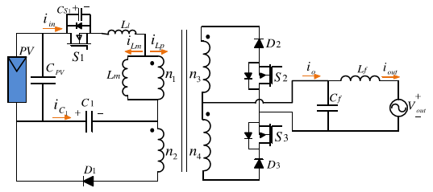
Fig. 1. MMC-STATCOM circuit configuration.
DESIGNG SOFTWARE AND TOOLS:
MAT LAB /SIMULATION Software and simu power systems tools are used. Mainly control system tools, power electronics and electrical elements tools are used.

